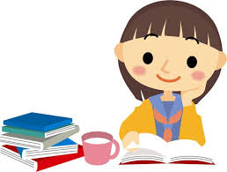

**The material is extremely useful, and cultivates considerable skills.**

**Topic 1: Why should Students enter university?**

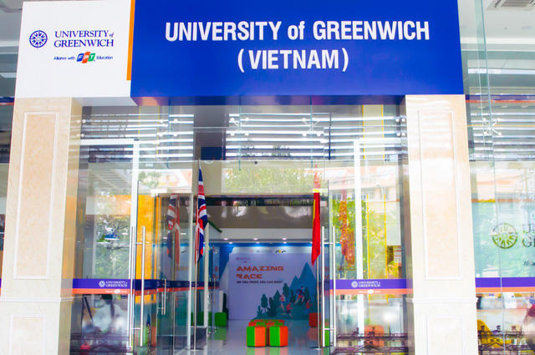

University is the place where students get knowledge and new experiences. Studying in the university gives a vast exposure to the student in his specified field. University builds a professional base in the student.

Till their higher school students used to study in various fields. They have to read different subjects which are not in their career streams. Therefore they attend college or universities to get ample knowledge of their field. Universities and colleges have experienced staff in diverse fields. Everyone is professional in their stream therefore students get the opportunity to learn from these persons(professors) various skills in their stream which is not possible while studying in higher school.

Secondly, various projects, researches, assignments, and practical scenarios are conducted in universities or colleges from where students get exposure and experience to various problems that they might have to face in their real-life while practicing. Like in dentistry the students have to work on the tooth for scaling, wiring, etc from which they get practical exposure.

Moreover, universities have huge libraries carrying thousands of books of different subjects and other study materials like fictional, non-fictional, journals, newspapers, reports which are huge sources of information for the students and teachers.

Various recreational activities are conducted in universities. Sports meet, youth festivals, Conferences, Seminars, Debates, Declamation contests, etc which also helps in getting new experiences.

As a whole, while studying in college or university students build confidence as a trait in themselves which is very essential to be successful in life. So I think people attend college to get exposure, experience, confidence, increased knowledge, career preparation as a whole.

**Topic 2: **Are parents best teachers?****

I do strongly agree the idea that parents are the best teachers. This I agree for following reasons.

The first teachers we have in our lives in most cases are our parents. They teach us to walk, to speak, and to have good manners before we reach he real world. ?More than even the professional teachers that we have in school, parents are generally the most involved in the development and education of children.

Almost for sure our parents are the best teachers at the beginning of our lives, which actually corresponds to the parents’ role in nature. Parents are most committed and involved in teaching their children; they have a kind of instinct to sacrifice a part of themselves for the betterment of their children. They love us and have great patience while passing down their knowledge to us. They wish us a success and thus will not teach us bad things. And of course, implicit learning occurs when children unconsciously copy some of their parents’ habits and styles of behavior.

During the second stage of child development, adolescence, parents can still be in the best position to offer advice even though the children might not accept it. In this case, perhaps the child’s friends would be the best teachers. Adolescents are notoriously rebellious in many cultures and may automatically reject some advice from their parents. My first marriage for instance, was solely a matter of doing the opposite when my parents tried to intrude in offering advice. So in such matters, parents should be much more flexible and be rather the partners with their children.

So we can see that being a teacher of growing child becomes more and more complicated case as the time passes and many parents are simply not able to meet the increased demands.

**Topic 3: Parents and teachers.**

Obviously, the earliest teachers we have in our lives in most cases are our parents, and they are generally the most involved in the development and education of their children. Yet neither are all parents good teachers nor are those good parents the best teachers. First of all, not all parents are good teachers. As normal individuals, some parents more or less have bad habits. Even though parents almost instinctively devote themselves to cultivating their offspring, the outcome might turn out to be a disappointment, for all children tend to unconsciously or subconsciously copy everything from their parents. Another deficiency of parents as teachers is the fact that most parents are lack of common sense of education.

All too often we observe some parents tend to pursue their cherished but failed dream by forcing their children to develop in a prearranged direction. Ironically, if their children did not follow the instructions, the children would be regarded as disobedient or allegedly rebellious. In fact, it is parents rather than their children that virtually disobey common senses.

Moreover, some parents are qualified as good teachers, but not all of them are the best ones. When children are in a preliminary school, it is not surprising that parents are capable of teaching their children almost every subject even better than professional teachers in the school. But the situation will not last long. We live in a world where knowledge is accumulated by multiplying and at the same time becomes more and more specialized.

Therefore, being a professional in a certain field today takes a much longer time than ever before. No parent is able to be professional in all fields, though they might be experts in one or more fields. Wise parents often release rather than charging their children as early as possible. They are aware of the possibility outside the family. Parents may, nevertheless, help their children much more than do good teachers. Most parts of children's education are virtually beyond teachers' reaches. It is parents that supplement. Psychology studies have shown us that parents' love sometimes has the astonishingly magic power to their children.

Albert Einstein's mother and Forest Gump's mother are both good examples. On the other hand, parents might do their children harm more than do bad teachers as well. The natures of those children whose parents have divorced are often severely distorted. In a word, it is rather superficial to simply say that parents are the best teachers.

**Topic 4: Are books more important than experience?**

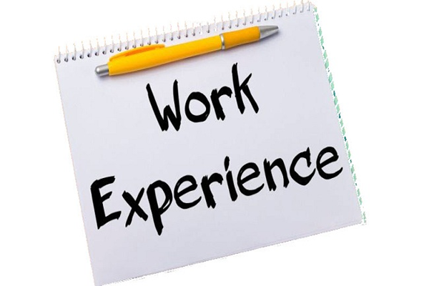

Many people have said that not everything that is learned is contained in books, while many people also say that we get most of our knowledge from books. In my point of view, the latter one is as important as, if not more important than the former one, Although not everything is contained in books, we have to learn most of the things in books. Among countless reasons, which influence the former one, I explore the most conspicuous aspects as follows:

The main reason I agree with the argument is that the knowledge contained in books is systematic. As we know, almost all the books are the children of the marriage of the author’s thought with the real world. In order to express themselves, they surely use a very systematic structure to form a book, which has a specific note of their thought and experiences. With the systematic structure, we can learn things gradually, by our own pace and we need not worry that if we had missed some of the important details because systematic structure never drops the essential points. What we only need to do is follow the instructions directed by the author and grasps the content by our consideration.

There is another reason that deserves some words here, however, is that learning by reading books is an efficient way of accumulating knowledge. In the ancient world, no books existed, and people should realize the world by exploring everything by themselves. This method apparently takes too much time and energy. But with the ready-made knowledge provided by the books put in front of us, why not take on it directly? It will save us a lot of time to take advantage of others’ thoughts and experiences than we explore them by ourselves.

It would not be too kindly disposed to the idea that not learning knowledge in books is not important. Of course, gaining knowledge from experience is not without advantages. Because experiencing life by oneself would be more impressive and could affect you for a lifetime. Such examples are not rated in our personal life.

In a word, to choose the way of gaining knowledge is something of a dilemma to the public because they sometimes are confused by the seemingly good qualities of learning by experiences, but neglect the most genuinely good aspect of learning by reading. For the reasons presented above, I strongly commit to the notion of reading, not by experiences.

Table of Contents

Topic 1: 1, 2

Topic 2: 2

Topic 3: 2, 3

Topic 4: 3, 4

Click here to enter text.

Source : <https://tienganh247.info/30-bai-van-mau-tieng-anh-cuc-hay-a3388.html>